Texas Dispute Resolution System™
Texas Rural Mediation Services™
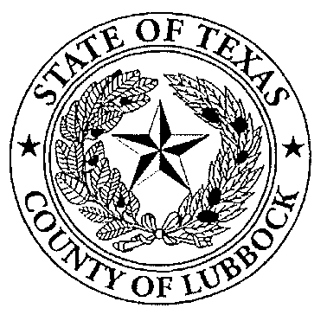

Contact:
Crystal Stone or D. Gene Valentini
For Immediate Release drc@co.lubbock.tx.us
(806) 775-1720
1-866-329-3522

Monsanto: Another Option for Peace in the Fields and at Home

Lubbock, Texas—February 21, 2008—With the recent partnership of Monsanto and the USDA Agricultural Mediation Program, Texas Rural Mediation Services™ will provide mediations for disputes involving the company and their customers in Texas and surrounding states, when necessary. The USDA Agricultural Mediation program is available in 33 other states, mostly serving agricultural and rural communities. For those states not served by the program, TRMS can provide mediation services as requested.

Monsanto uses mediation as an informal measure to handle disputes in a non-adversarial manner in conjunction with many other options, the last being litigation. Mediation can be used to resolve issues with seed quality and customer, representative and dealer stewardship of the products.

Texas Rural Mediation Services™ is the USDA Agricultural Mediation Program in Texas and is administered by the Dispute Resolution Department in Lubbock County. TRMS is a state-wide program dedicated to providing producers, their creditors, and others involved with USDA programs with access to Alternative Dispute Resolution Services.

To request more information, please contact us today at (806)775-1720 or toll-free at 1-866-329-3522.

-30-

This is a service of Texas Rural Mediation Services™, a program operated by the Texas Dispute Resolution System™, which promotes and supports mediation activities as designated by the Governor’s office and the U.S. Department of Agriculture to serve the state of Texas.

